Mini Project Report on
Analyze Employee and Salary Distribution
Subject: Big Data Analytics (CSL702)
B.E. Computer Engineering

Submitted by

Name | Roll No.
Tasmiya Kandhal | 231213
Numa Kazi | 231214
Rabiya Khan | 231229
Arfa Shaikh | 231248

Under the guidance of
Er. Ahlam Ansari



Department of Computer Engineering
M. H. Saboo Siddik College of Engineering,
Saboo Siddik Polytechnic Road, Clare Road,
Byculla, Mumbai - 400008

University of Mumbai (AY 2026-27)

Abstract
Organisations store large volumes of employee records, and understanding how salaries are distributed across departments, job titles, genders and experience levels is important for fair and informed pay decisions. This mini project analyses an employee dataset of 2,639 records using Apache Spark (PySpark) and Spark SQL. The data is loaded, cleaned and explored to compute salary statistics, department-wise headcount and pay, gender-wise pay, the highest-paying job titles, salary bands and the effect of experience on salary. The results are presented as tables and charts. The analysis shows that salaries are strongly right-skewed (mean of about 58,137 against a median of about 46,770), that job title and experience influence pay far more than department, that headcount is spread evenly across the six departments, and that the gender difference in average salary is small.

1. Introduction
Human resource data holds valuable information about how an organisation pays its people. Studying salary distribution helps management identify pay patterns, spot unusually high or low salaries, and check whether pay is consistent across departments and groups. As data grows, tools that can process it in parallel become necessary. Apache Spark is a widely used big data engine that supports in-memory, distributed processing with simple APIs in Python (PySpark) and SQL.
In this project we use PySpark to analyse employee and salary data from the HR records of a company, and use Matplotlib and Seaborn to visualise the findings.

2. Problem Statement
To analyse the distribution of employees and their salaries across departments, job titles, gender and experience using big data tools, and to present meaningful insights that describe how pay is spread within the organisation.

3. Objectives
- To load and clean an employee dataset using Apache Spark.
- To compute overall salary statistics such as mean, median, standard deviation, minimum, maximum and quartiles.
- To analyse headcount and average salary by department.
- To compare average salary between genders.
- To find the highest-paying job titles and study the effect of experience on salary.
- To visualise the results and summarise the key insights.
- To build an interactive dashboard that lets users filter the data and explore the results.

4. Tools and Technologies
Tool | Purpose
Python 3 | Programming language used for the entire analysis
Apache Spark (PySpark) | Loading, cleaning and processing the data using DataFrames
Spark SQL | Running SQL queries for grouping and aggregation
Pandas | Converting small result sets for plotting
Matplotlib and Seaborn | Creating charts and visualisations
Google Colab | Cloud notebook environment used to run the code
HTML, CSS and JavaScript | Building the interactive dashboard (frontend) and filtering the data in the browser
Chart.js | Drawing the interactive charts shown in the dashboard

5. Dataset Description
The dataset used is the "Salary Prediction of Data Professions" dataset from Kaggle. It contains HR records of a hypothetical company, with 2,639 employee records and the following attributes: first name, last name, sex, date of joining, current date, designation, age, salary, unit (department), leaves used, leaves remaining, ratings and past experience.
For the analysis, the following columns were used and renamed for clarity:
Original column | Name used | Description
SEX | gender | Gender of the employee (F or M)
DESIGNATION | job_title | Job role of the employee
UNIT | department | Department of the employee
PAST EXP | experience_years | Past work experience in years
SALARY | salary | Salary of the employee

The dataset has six departments: Marketing, Management, IT, Finance, Web and Operations. After checking for missing and invalid salary values, all 2,639 records were retained.

6. Methodology
The analysis follows a simple pipeline with five stages:
- Data loading: the CSV file is read into a Spark DataFrame with the schema inferred automatically.
- Data preparation: columns are renamed, experience is converted to a numeric type, and a unique employee identifier is added.
- Data cleaning: records with missing salary or department, and records with a non-positive salary, are removed. No records were removed in this dataset.
- Analysis: Spark SQL and DataFrame functions are used to compute statistics, group-wise averages, salary bands and experience groups.
- Visualisation: the aggregated results are converted to Pandas and plotted using Matplotlib and Seaborn.

7. Implementation
The key parts of the PySpark implementation are shown below.

7.1 Loading and cleaning the data
spark = SparkSession.builder.appName("EmployeeSalary").master("local[*]").getOrCreate()
df = spark.read.csv("employees.csv", header=True, inferSchema=True)
for old, new in COLUMN_MAP.items():
df = df.withColumnRenamed(old, new)
df = df.dropna(subset=["salary", "department"]).filter(F.col("salary") > 0)
df.createOrReplaceTempView("employees")

7.2 Salary statistics and quartiles
df.select(F.mean("salary"), F.stddev("salary"),
F.min("salary"), F.max("salary")).show()
q1, med, q3 = df.approxQuantile("salary", [0.25, 0.5, 0.75], 0.01)

7.3 Department-wise analysis using Spark SQL
dept = spark.sql("""SELECT department, COUNT(*) AS headcount,
ROUND(AVG(salary),0) AS avg_salary, MAX(salary) AS max_salary
FROM employees GROUP BY department ORDER BY avg_salary DESC""")

7.4 Gender and job title analysis
gender = spark.sql("""SELECT gender, COUNT(*) AS headcount,
ROUND(AVG(salary),0) AS avg_salary FROM employees GROUP BY gender""")
spark.sql("""SELECT job_title, ROUND(AVG(salary),0) AS avg_salary
FROM employees GROUP BY job_title ORDER BY avg_salary DESC LIMIT 5""")

8. Results and Analysis

8.1 Overall salary statistics
Measure | Value
Total employees | 2,639
Mean salary | 58,137
Standard deviation | 36,877
Minimum salary | 40,001
Maximum salary | 388,112
First quartile (Q1) | 43,343
Median | 46,770
Third quartile (Q3) | 50,368

The mean salary is noticeably higher than the median, which indicates that the distribution is right-skewed: most employees earn close to the lower end of the range while a small number of senior employees earn very high salaries. The salary distribution is shown in Figure 1.
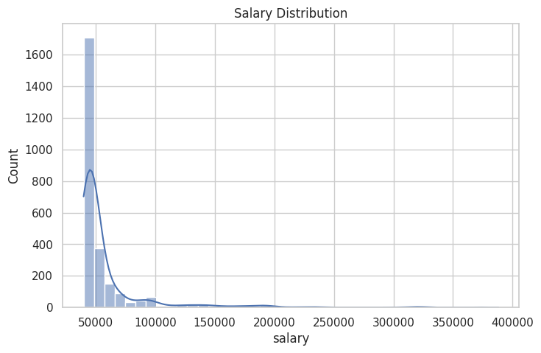
Figure 1: Salary distribution
Most employees fall in the range of about 40,000 to 50,000, and the count drops sharply at higher salaries, with a long tail extending up to about 388,000.

8.2 Department-wise headcount and salary

Department | Headcount | Average salary | Maximum salary
Marketing | 438 | 59,318 | 388,112
Management | 425 | 59,187 | 368,887
IT | 461 | 58,998 | 355,337
Finance | 446 | 58,599 | 375,647
Web | 431 | 57,203 | 324,129
Operations | 438 | 55,478 | 301,872

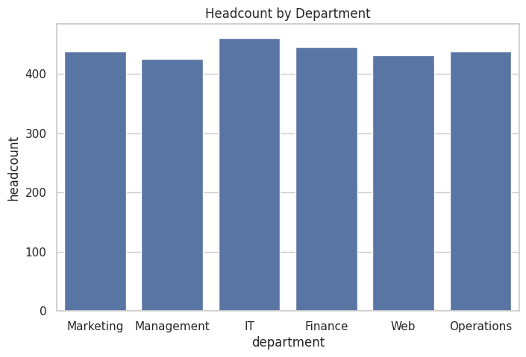
Figure 2: Headcount by department
Headcount is spread evenly across the six departments, with every department having between 425 and 461 employees. Average salaries are also close, ranging from 55,478 (Operations) to 59,318 (Marketing). This shows that the department alone does not explain large differences in pay.
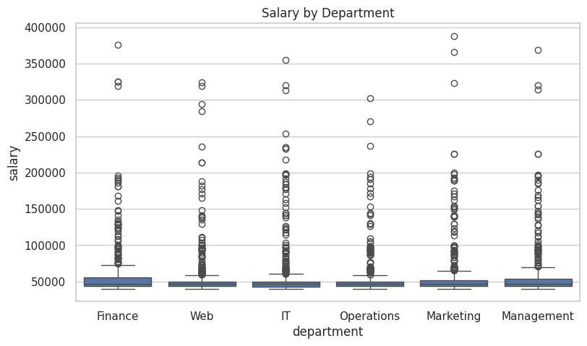
Figure 3: Salary distribution by department
The box plot shows that every department has a similar median salary and a similar compact range for most employees, together with many high-value outliers. These outliers are senior positions such as directors and senior managers, so they are genuine values and were retained in the analysis.

8.3 Gender-wise salary
Gender | Headcount | Average salary
F | 1,344 | 59,143
M | 1,295 | 57,093

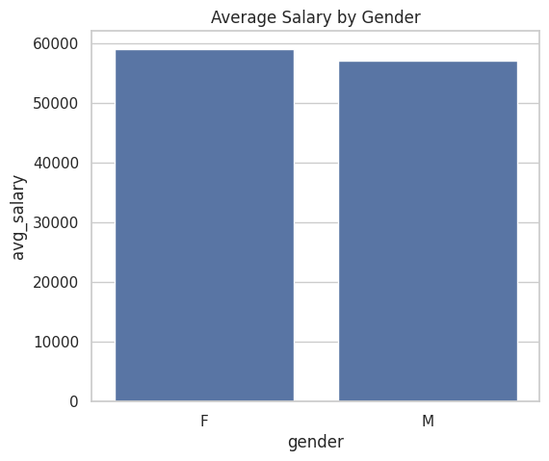
Figure 4: Average salary by gender
The two groups are nearly equal in size. The average salary of female employees is about 2,050 higher than that of male employees, a difference of roughly 3.5%. This is a small gap. Because this comparison does not control for job title or experience, it should not be treated as proof of any pay advantage or disadvantage.

8.4 Highest-paying job titles
Job title | Average salary
Director | 286,971
Senior Manager | 178,664
Manager | 126,273
Associate | 87,203
Senior Analyst | 59,901

Job title has a very strong influence on salary. A Director earns on average almost five times as much as a Senior Analyst. This is the main reason for the skewed overall distribution.

8.5 Salary bands
To segment employees, salaries were divided into four bands using the quartiles: Low (below Q1), Lower-mid (Q1 to median), Upper-mid (median to Q3) and High (above Q3). The counts were 638, 676, 641 and 684 employees respectively. Since the bands are defined by quartiles, they are close to equal in size by design, so they are used only to group employees and not as a finding in themselves.

8.6 Effect of experience on salary
Experience group | Average salary
0-4 years | 49,007
5-9 years | 108,211
10-14 years | 194,722
15+ years | 268,643

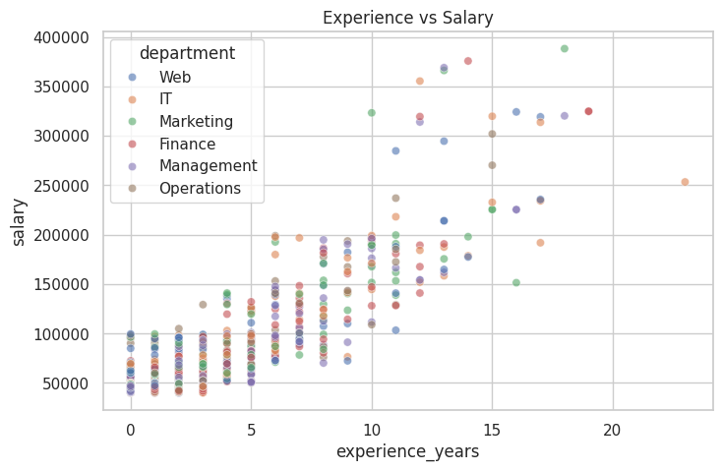
Figure 5: Experience versus salary
Salary rises steadily with experience. Average pay increases from about 49,000 for employees with less than five years of experience to about 269,000 for those with fifteen or more years. The scatter plot confirms this upward trend, and the points for all departments follow the same pattern, which again shows that experience and seniority matter more than the department.

9. Interactive Dashboard
The Spark analysis produces tables and static charts. To make these results easier to explore, a web dashboard was built as the frontend of the project. It lets a user choose a department, job title, gender or experience group and see the statistics and charts update immediately.

9.1 Features
- Filters: department, job title, gender and experience group (0-4, 5-9, 10-14 and 15+ years), with a reset button.
- Summary strip: number of employees, mean salary, median salary, the middle 50% range of salaries (Q1 to Q3) and the highest salary.
- Salary distribution histogram with the median and mean marked. The heading changes with the filters and states how far the mean is above the median.
- Bar charts of average salary by job title, department and experience group, and a gender comparison showing the difference in average pay.
- A job title summary table with headcount, average, lowest and highest salary.
- A responsive layout that works on phones, tablets and desktops, in both light and dark mode.

9.2 Implementation
The dashboard is a single HTML page. JavaScript performs the filtering and calculates the statistics, and Chart.js draws the charts. The columns needed for the analysis (gender, job title, department, salary and experience) are embedded in the page, without employee names, so no server or database is required. The page opens in any modern web browser with an internet connection, because Chart.js is loaded from a CDN. The Spark pipeline remains the main analysis; the dashboard presents the same measures and recomputes them in the browser for the selected filters.
The dashboard values match the Spark results reported in Section 8, including the overall mean salary, the department, gender and job title averages, and the experience group averages. The quartiles in the dashboard are calculated exactly, whereas approxQuantile in Spark gives approximate values, so Q1, the median and Q3 can differ slightly from Table 8.1.

9.3 Screenshots
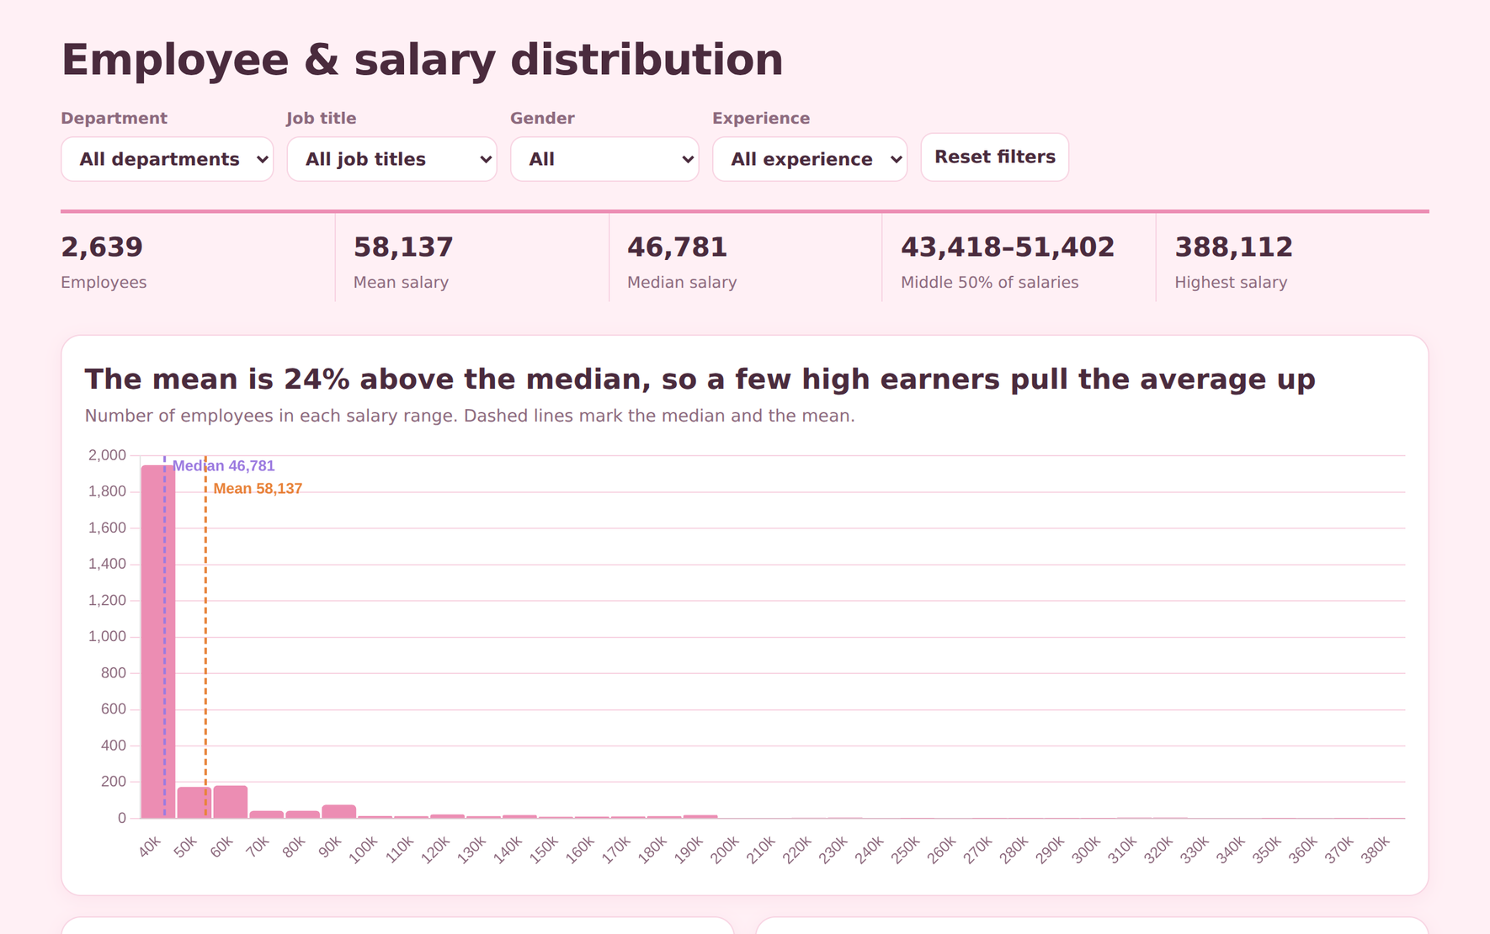
Figure 6: Dashboard overview with summary strip and salary histogram
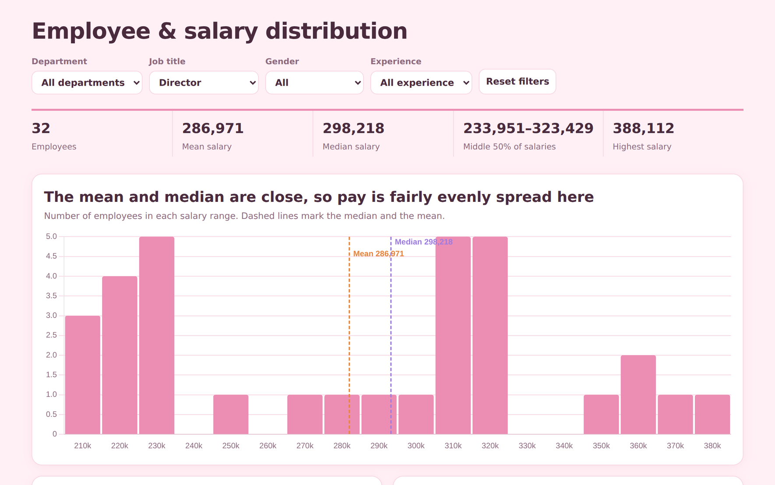
Figure 7: Dashboard with the Director job title selected

10. Key Insights
- Salaries are right-skewed: the mean (58,137) is well above the median (46,770).
- Job title and experience are the main drivers of salary; department has little effect.
- Headcount is balanced across the six departments.
- The gender difference in average salary is small (about 3.5%) and was not adjusted for job title or experience.
- High-salary outliers correspond to senior roles and are genuine values.

11. Limitations
- The dataset represents a hypothetical company, so the findings describe this dataset and not a real organisation.
- With 2,639 records the data is small. Spark was used to demonstrate a scalable workflow that would work unchanged on much larger HR datasets.
- The analysis is descriptive; it does not establish the causes of pay differences.

12. Conclusion
This project analysed the employee and salary distribution of 2,639 employees using PySpark and Spark SQL. The analysis showed that salaries are concentrated at the lower end with a long tail of high earners, that pay is driven mainly by job title and experience rather than by department, and that the gender difference in average pay is small. The project demonstrates how a big data tool can be used to clean, aggregate and visualise HR data to support clear, evidence-based insights. An interactive dashboard was also built so that these results can be explored through filters.

13. Future Scope
- Apply the same pipeline to a much larger dataset stored on HDFS or a cloud data lake.
- Compare gender pay after controlling for job title and experience.
- Build a salary prediction model using Spark MLlib.
- Extend the dashboard with data upload, employee-level search and a salary prediction view.

References
- Kaggle, "Salary Prediction of Data Professions" dataset (krishujeniya). https://www.kaggle.com
- M. Zaharia et al., "Apache Spark: A Unified Engine for Big Data Processing," Communications of the ACM, vol. 59, no. 11, pp. 56-65, 2016.
- Apache Spark Documentation, PySpark and Spark SQL Guide. https://spark.apache.org/docs/latest/
- J. D. Hunter, "Matplotlib: A 2D Graphics Environment," Computing in Science & Engineering, vol. 9, no. 3, pp. 90-95, 2007.
- M. L. Waskom, "seaborn: statistical data visualization," Journal of Open Source Software, vol. 6, no. 60, 2021.

